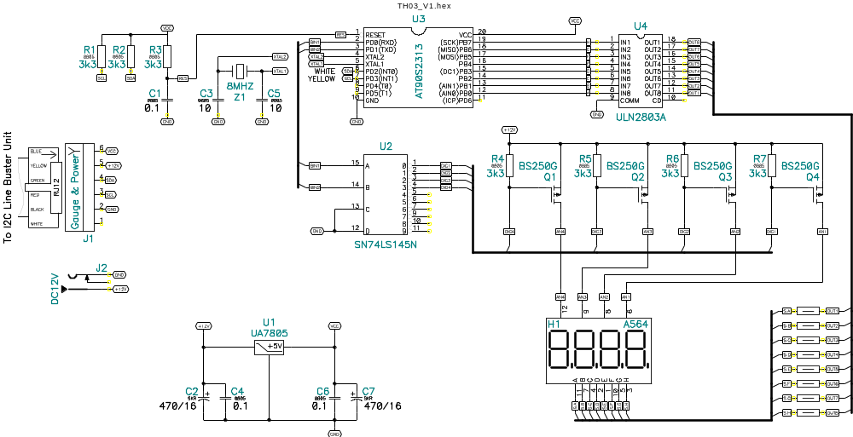
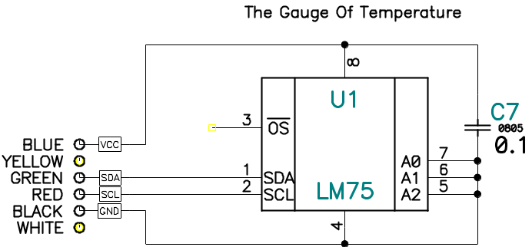

 |  |  | Display Unit
Printed Circuit Board T04_DSP.PCB
 | 1 | 8MHZ | Crystal | Z1 | RK169
 | 2 | 470mkF/16V | Electrolytic capacitor | C2, C7 | Type SKR
 | 1 | A564 | Four Digits Display | H1 | red
 | 1 | AT90S2313 | Processor | U3 | DIP20
 | 4 | BS250G | Transistor | Q1…Q4 | TO93G
 | 3 | 0,1 mkF | SMD Capacitor | C1,C4,C6 | 0805
 | 2 | 10 pF | SMD Capacitor | C3, C5 | 0805
 | 1 | Jack 2.1 mm | Female Connector | J2 |  | DC12V
 | 1 | Phone 6/6 | Female Phone Connector | J1
 | 8 | 100 | Resistor 0.250W | R8…R15
 | 6 | 3k3 | SMD Resistor | R1, R2, R4…R7 | 0805
 | 1 | 100k | SMD Resistor | R3 | 0805
 | 1 | SN74LS145N | BCD-to-decimal Decoder | U2 | DIP16
 | 1 | UA7805 | Voltage regulator +5V | U1 | TO220
 | 1 | ULN2803A | Eight Stage Driver | U4 | DIP18
 | 1 |  | Telephone Cable 6/6 1.5m | With one plug RJ45
 |  |  | Gauge Unit
Printed Circuit Board T04_LM75.PCB
 | 1 | LM75 | Gauge of Temperature I2C | U1 | SO8
 | 1 | 0.1 mkF | SMD Capacitor | C1 | 0805

